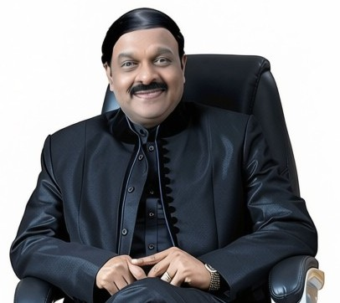
Chief Patron
Dr.A.C.Shanmugam
B.A.LLB,FIMSA,FRCPS(Glosgow ,UK)
Founder Chairman
Dr.M.G.R.E & RI,Chennai & RRGI,Bengaluru


Patron
Sri..A.C.S ArunKumar
B.Tech(Hons).,LMISTE.,MIET.,(UK).,LMCSI.,
President
Dr.M.G.R.E & RI,Chennai & RRGI,Bengaluru

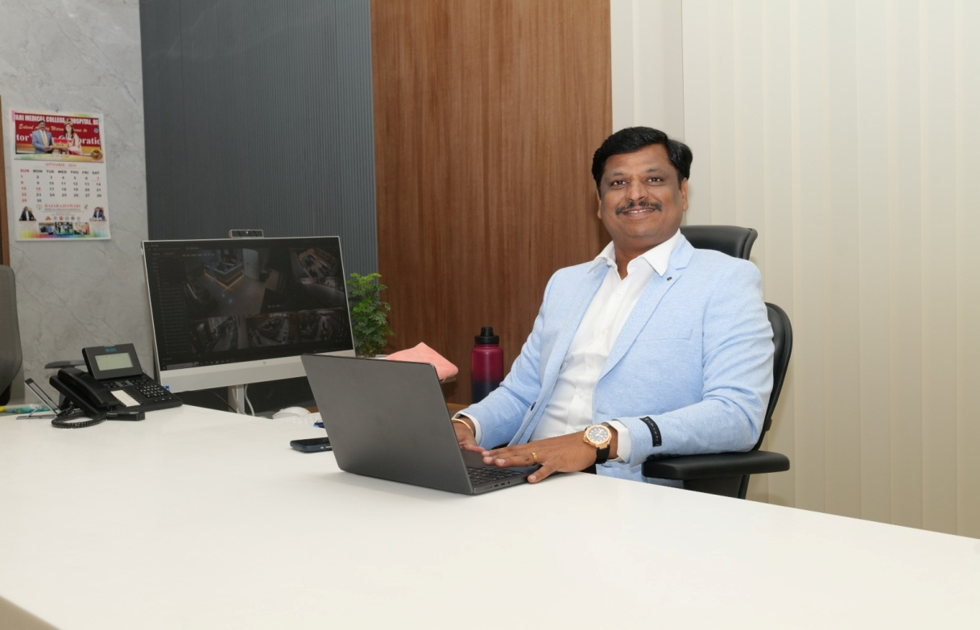
Dr. S. Vijayanand
M.Tech.,Ph.D
Executive Director, RRGI

BATCH 2021-2025

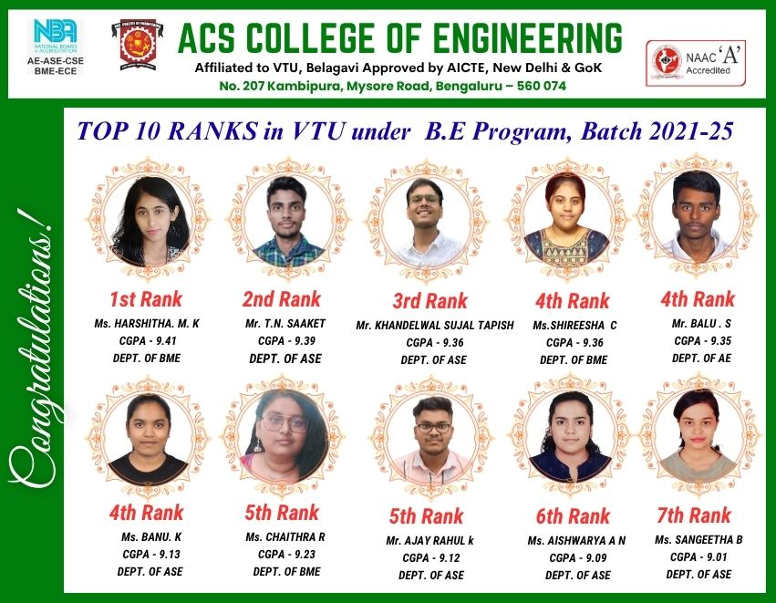

BATCH 2022- 2026

